ONEWAY ACC BY DAW
/STATISTICS DESCRIPTIVES HOMOGENEITY WELCH
/PLOT MEANS
/MISSING ANALYSIS.

Oneway

Notes
Output Created |  | 05-May-2019 23:27:12
Comments
Input | Active Dataset | DataSet0
Input | Filter | <none>
Input | Weight | <none>
Input | Split File | <none>
Input | N of Rows in Working Data File | 30
Missing Value Handling | Definition of Missing | User-defined missing values are treated as missing.
Missing Value Handling | Cases Used | Statistics for each analysis are based on cases with no missing data for any variable in the analysis.
Syntax |  | ONEWAY ACC BY DAW  /STATISTICS DESCRIPTIVES HOMOGENEITY WELCH  /PLOT MEANS  /MISSING ANALYSIS.
Resources | Processor Time | 00 00:00:00.141
Resources | Elapsed Time | 00 00:00:00.151

[DataSet0]

Descriptives
 | N | Mean | Std. Deviation | Std. Error | 95% Confidence Interval for Mean
 |  |  |  |  | Lower Bound | Upper Bound
1-3 days a week | 12 | 80.9167 | 18.96628 | 5.47509 | 68.8661 | 92.9673
3-5 days a week | 5 | 112.0000 | 17.84657 | 7.98123 | 89.8406 | 134.1594
5-7 days a week | 13 | 101.0769 | 28.10831 | 7.79584 | 84.0912 | 118.0626
Total | 30 | 94.8333 | 25.60722 | 4.67522 | 85.2714 | 104.3952

Descriptives
 | Minimum | Maximum
1-3 days a week | 50.00 | 123.00
3-5 days a week | 84.00 | 128.00
5-7 days a week | 57.00 | 150.00
Total | 50.00 | 150.00

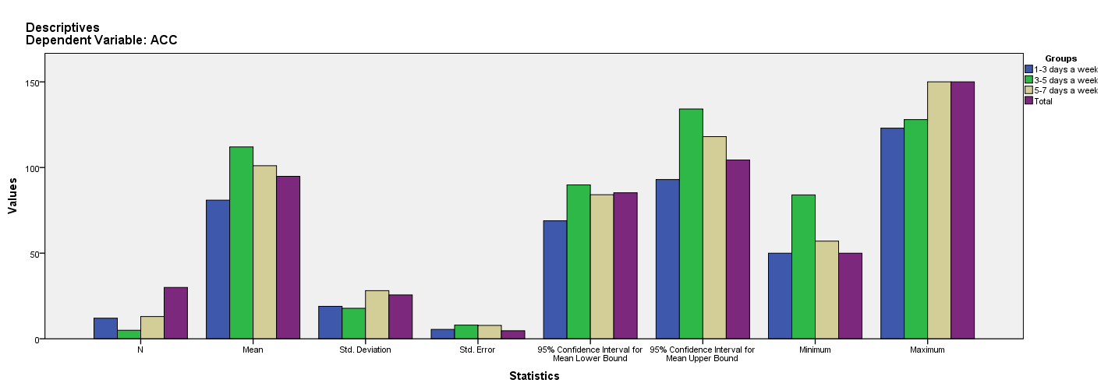

Test of Homogeneity of Variances
ACC
Levene Statistic | df1 | df2 | Sig.
2.045 | 2 | 27 | .149

ANOVA
ACC
 | Sum of Squares | df | Mean Square | F | Sig.
Between Groups | 4304.327 | 2 | 2152.163 | 3.950 | .031
Within Groups | 14711.840 | 27 | 544.883
Total | 19016.167 | 29

Robust Tests of Equality of Means
ACC
 | Statisticª | df1 | df2 | Sig.
Welch | 5.506 | 2 | 12.510 | .019
a. Asymptotically F distributed.

Means Plots

